SMART IRRIGATION USING IOT

**AIM**: Automation of irrigation system using IOT.

**REQUISITS**: Internet Of Things (IOT), Wi-fi , Moister sensor, Humidity sensor, And Temperature sensor.

**PROPOSED SYSTEM:** The block diagram of proposed systems are shown below…

1.Transmission system: The above figure shows that main block diagram of Irrigation control system. In below model we used raspberry pi, moisture and temperature sensor along with motor.

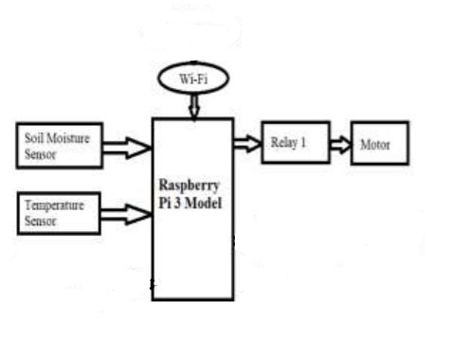

2.Sensors: A sensor is a device, module, or subsystem whose purpose is to detect events or changes in its environment and send the information to other electronics, frequently a computer processor.

• Soil moisture sensor- used to measure the moisture content of the soil.

• Temperature sensor - used to detect the temperature of the soil.

1.moister sensor 2.temperature sensor

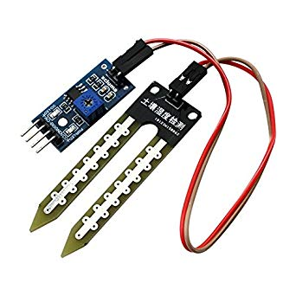 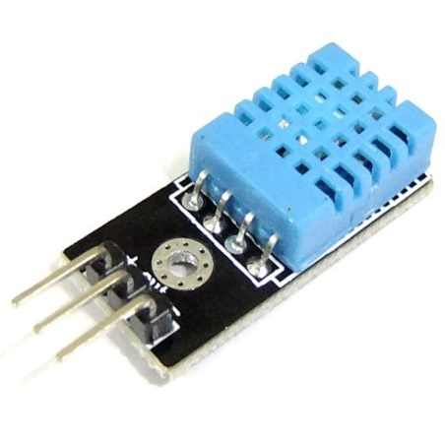

3.Raspberrypi: Raspberry Pi is a small sized single board computer which is capable of doing the entire job that an average desktop computer does like spread sheets, Word processing, Internet, Programming, Games etc. It contain 1GB RAM, 2 USB, ARM V8 Processor and an Ethernet port, HDMI & RCA ports for display,3.5mm Audio jack, SD card slot (bootable), General purpose I/O pins, runs on 5v.

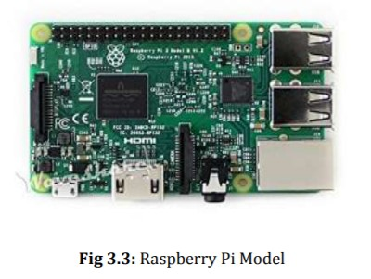

**WORK FLOW OF THE SYSTEM:**

Step 1: Start.

Step 2: The system can be initialised on Raspberry Pi.

Step 3: The soil moisture sensor checks the soil moisture level constantly.

Step 4: The sensor constantly senses the temperature and humidity of the field and updates the date in the web server.

Step 5: If the permissible level of water is less , then the relay which is connected to the Raspberry Pi will turn ON the motor.

Step 6: Similarly, if the soil becomes dry, the motor which is connected to the relay will be turned ON to wet the field.

Step 7: If the step 6 is completed, it will go to the step 3.

Step 10: Similarly, if the step 5 is over, the command will go to the step 3.

**CONCLUSION:** The smart irrigation system is suitable and cost effective for advance water resources for agricultural production. The system would provide feedback control system which will monitor and control all the activities of plant growth and irrigation system efficiently. If rain gun sensor can be added so that when it rains there won’t be floods. Rain water harvesting can be done and this harvested water can be used to irrigate fields. We can also include many more water quality sensors that affect the crops.

**TEAM:**

1. P.Srinivasa Bhargav.
2. P.Veda Upasan.
3. T. Jhansi Vijay Krishna.